Volunteers are needed to participate in an asthma research study testing an investigational drug for asthma.

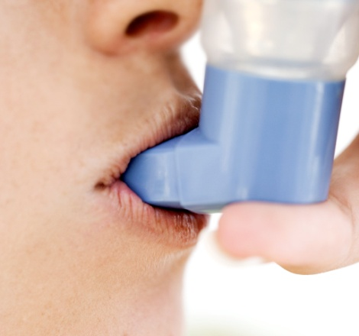

**To Qualify:**

* Ages 12 years and older
* Diagnosis of Asthma
* Currently using an inhaled steroid

The study will consist of up to 8 office visits and 6 phone calls over a period of up to 15 weeks.

Qualified volunteers receive investigational study drug or placebo and related testing at no cost

and will be compensated for time and travel.

**301.948.4066**

[**Family**](http://www.CRIminnesota.com) **Allergy & Asthma Care**

**www.familyallergycare.com**